I.

1. A relation is said to be in 3NF if it’s in 2NF and there is no non-prime attribute that is transitively dependent on any key in the relation, i.e. if A -> B and B -> C, then B -> A.

2. In a ternary relationship, we have three tables which are resolved using a link table. For example, for a transaction for a house we can have: House, Client, Seller, all being referenced in the Transaction.

II.

1.

a.

b.

CREATE TABLE ClustersGalaxy(

CGID INT PRIMARY KEY,

CGName VARCHAR(50),

CGMass INT,

CGType INT CHECK (CGType>=1 AND CGType<=3))

CREATE TABLE GroupsGalaxy(

GGID INT PRIMARY KEY,

GGName VARCHAR(50),

GGDiameter INT,

GGMass INT)

CREATE TABLE Galaxies(

GID INT PRIMARY KEY,

GName VARCHAR(50),

GDiameter INT,

GCategory VARCHAR(50) CHECK (GCategory = 'elliptical' OR GCategory = 'spiral' OR GCategory = 'irregular'),

GMass INT,

GGID INT REFERENCES GroupsGalaxy(GGID),

CGID INT REFERENCES ClustersGalaxy(CGID),

CHECK ((GGID IS NULL OR CGID IS NULL) AND (GGID IS NOT NULL OR CGID IS NOT NULL)))

CREATE TABLE Stars(

StID INT PRIMARY KEY,

StName VARCHAR(50),

StAge INT,

StMetallicity DECIMAL(5,2),

GID INT REFERENCES Galaxies(GID))

CREATE TABLE PlanetarySystems(

PSID INT PRIMARY KEY,

StID INT REFERENCES Stars(StID))

CREATE TABLE Planets(

PID INT PRIMARY KEY,

PName VARCHAR(50),

PSID INT REFERENCES PlanetarySystems(PSID))

CREATE TABLE Satellites(

SID INT PRIMARY KEY,

SName VARCHAR(50),

PID INT REFERENCES Planets(PID))

2.

a.

SELECT Stars.StID FROM Stars

WHERE Stars.GID IN (SELECT GID FROM Galaxies WHERE GName = 'Milky Way')

AND

(Stars.StID IN

(SELECT Stars.StID FROM Stars

INNER JOIN

PlanetarySystems ON PlanetarySystems.StID = Stars.StID

INNER JOIN

Planets ON PlanetarySystems.PSID = Planets.PSID

GROUP BY Stars.StID

HAVING COUNT(\*) >= 5)

OR Stars.StID IN

(SELECT Stars.StID FROM Stars

INNER JOIN

PlanetarySystems ON PlanetarySystems.StID = Stars.StID

INNER JOIN

Planets ON PlanetarySystems.PSID = Planets.PSID

INNER JOIN

Satellites ON Satellites.PID = Planets.PID

GROUP BY Stars.StID)

)

b.

SELECT ClustersGalaxy.CGName, Galaxies.GName FROM Galaxies

INNER JOIN

ClustersGalaxy ON Galaxies.CGID = ClustersGalaxy.CGID

WHERE ClustersGalaxy.CGType = 2

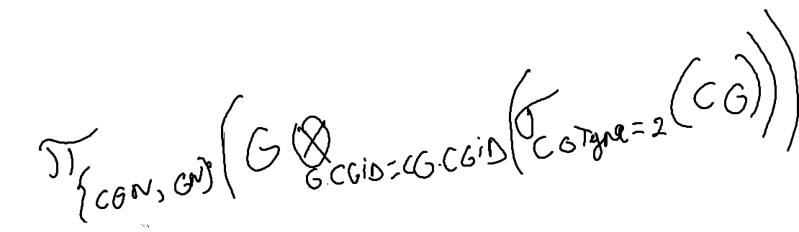

IV.

